POWER BI MODULE END ASSIGMENT
BY FATHIMA RESMIN F
OBJECTIVE
The main objective of this project is to create an interactive Power BI Sales Dashboard by collecting, preparing, cleaning, and analysing sales data. The project aims to convert raw data into meaningful information using SQL, Power BI, charts, tables, KPIs, and different visualizations. It helps to analyse sales, profit, orders, products, regions, and yearly trends and present the results in a simple and interactive dashboard for better understanding and decision-making.
DATA CLEANING AND LOADING
a) Import the dataset into Power BI using Power Query Editor.
b) Perform the necessary data cleaning steps to prepare it for analysis, including:
I) Handling missing values in columns.
ii) Removing duplicate rows.
ii) Standardizing the Order Date column to a consistent date format.
c) Load the cleaned dataset into the Power BI model.
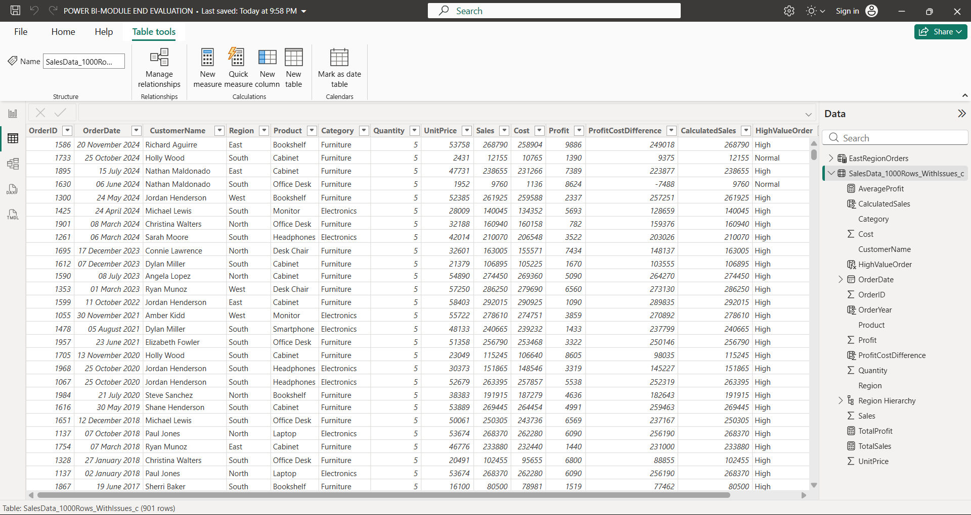
CLEANED DATA

* Checked and corrected inconsistent values in the Unit Price column..
* Checked and standardized values in the Cost column...
* Converted Quantity into the appropriate Number format.
* Formatted Unit Price, Sales, Cost, and Profit as numerical values.
* Converted Order Date into the proper Date format..
* Identified and handled null or missing values.
VISUALIZATIONS AND INSIGHTS
- Create a Pie Chart showing order distribution across different regions
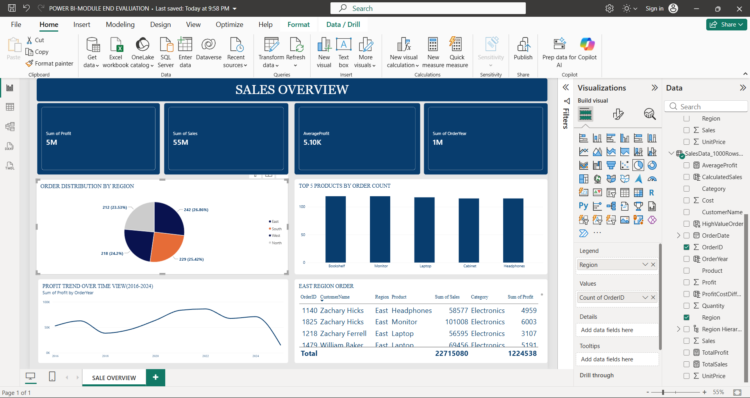

b) Create a Column Chart to display the top 5 trending products based on the number of times each product was ordered.

c) Create a Line Chart to show the profit trend over time.
DASHBOARD

* Different visuals like Cards, Pie Chart, Bar Chart, Line Chart, and Table were used.
* Cards show important values like total sales, profit, and orders.
* Pie Chart shows the order distribution in different regions.
* Bar Chart helps to compare different products and their order counts.
* Line Chart shows the profit trend over time.
* Table shows detailed information about customers, products, sales, and profit.
* Different categories, products, and regions are used for better comparison.
* The dashboard helps to understand the data quickly.
* It helps to identify top products, sales, and profit.
* It makes data analysis and decision-making easier.
* All important information can be viewed in one placeE

? How the Dashboard Helps Increase Profit
* It helps to identify high-profit products. It shows which products have low profit, so the business can improve or reduce them.It helps to find the best-performing regions.
It shows sales and profit trends, which helps in planning future sales.It helps the business focus on profitable products and customers.It supports better pricing and sales decisions.

DAX CALCULATIONS
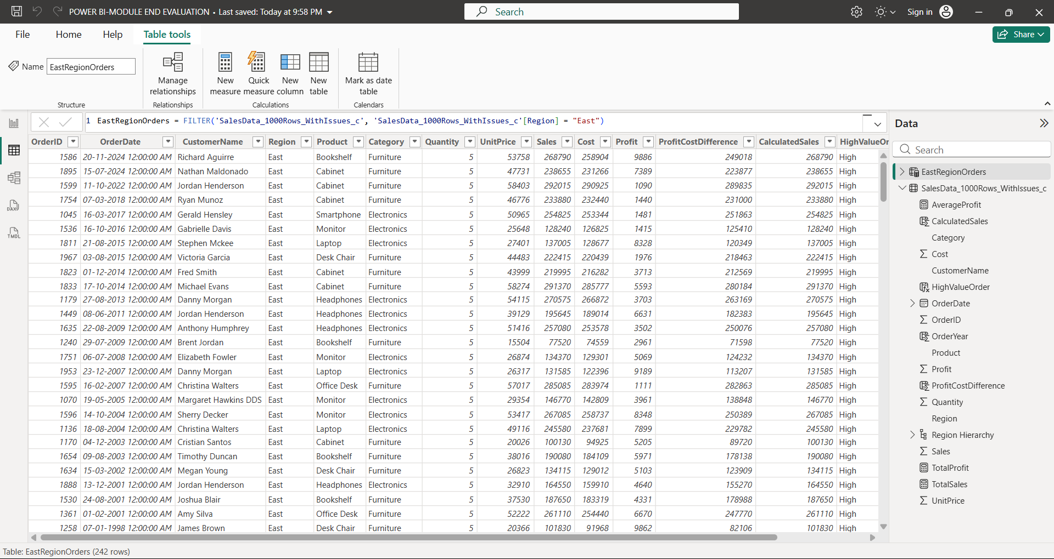
a) Create a Calculated Table named EastRegionOrders that filters and displays only the orders from the East region

EastRegionOrders = FILTER('SalesData_1000Rows_WithIssues_c', 'SalesData_1000Rows_WithIssues_c'[Region] = "East")
Used with this funtion created new table in power bi uesing calculated table

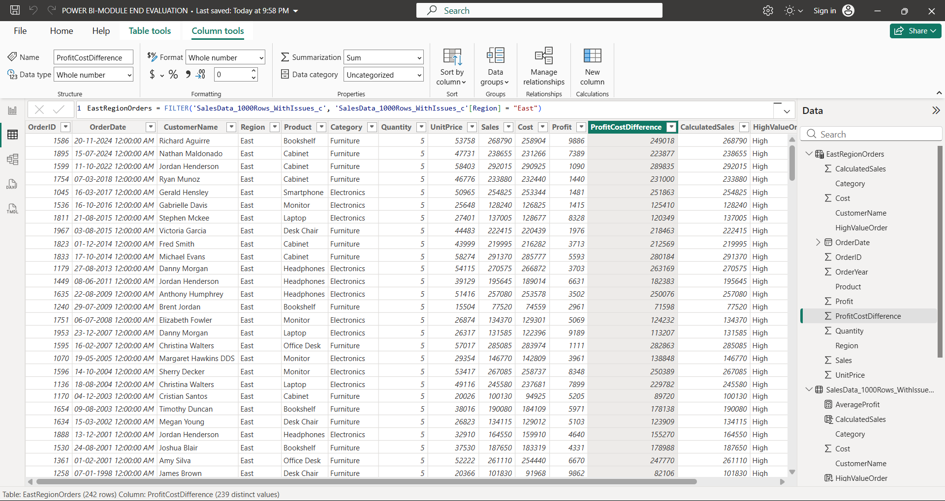
- Create a Calculated Column to compute the difference between the Profit and Cost columns. Name it Profit Cost Difference.
East Region Orders = FILTER ('SalesData_1000Rows_WithIssues_c’, Sale Data_1000Rows_WithIssues_c'[Region] = "East")
Used this function created calculated column by region data
- Create a Calculated Measure to find the total profit earned. Name it Total Profit
Total Profit = SUM('SalesData_1000Rows_WithIssues_c'[Profit])
With sum function create calculated measure in sale table

OVER VIEW OF MODULE END ASSIGMENT I N POWER BI

Data Cleaning
First, the data was cleaned and prepared for analysis. Unwanted data and errors were removed, and the data was organized properly. This helped to make the dataset accurate and ready for creating visuals and analysis.

Creating New Columns
New calculated columns were created based on the available data. These columns helped to get additional information and made the data easier to analyse. Different categories and values were used to create meaningful columns.

Creating Measures
Different measures were created in Power BI to calculate important values such as Total Sales, Total Profit, Average Profit, and Order Count. These measures were used in the dashboard to show key business information.

Removing Unwanted Column
Unnecessary columns that were not required for the analysis were removed from the dataset. This made the data more organized and easier to work with.

Creating Visualizations
Different visualizations were created using the cleaned data. Bar charts, Pie charts, Line charts, Cards, and Tables were used to represent the data clearly. These visuals helped to compare products, categories, regions, sales, and profit.

Creating Dashboards
Multiple dashboards were created using different visuals and measures. The dashboards provide an overall view of the sales and profit performance. Cards were used to show important values, while charts were used for comparison and trend analysis.

Dashboard Analysis
The dashboard helps to identify top-performing products, profitable regions, sales performance, and profit trends. It makes the data easy to understand and helps in making better business decisions.

Overall Project

Overall, the project involved data cleaning, creating new columns, creating measures, removing unwanted columns, creating visualizations, and designing dashboards in Power BI. The final dashboards provide useful insights from the data and help users understand sales and profit performance easily.

